

**RAJALAKSHMI ENGINEERING COLLEGE**

## VISION & MISSION OF

**RAJALAKSHMI ENGINEERING COLLEGE**

## Vision of the Institute:

To be an institution of excellence in Engineering, Technology and Management Education & Research. To provide competent and ethical professionals with a concern for society.

## Mission of the Institute:

**M1**: To impart quality technical education imbibed with proficiency and humane values.

**M2:** To provide right ambience and opportunities for the students to develop into creative, talented and globally competent professionals.

**M3:** To promote research and development in technology and management for the benefit of the society.



**RAJALAKSHMI ENGINEERING COLLEGE**

**B. E. ARTIFICIAL INTELLIGENCE AND DATA SCIENCE**

## VISION:

* To promote highly Ethical and Innovative Computer Professionals through excellence in teaching, training and research.

## MISSION:

* To produce globally competent professionals, motivated to learn the emerging technologies and to be innovative in solving real world problems.
* To promote research activities amongst the students and the members of faculty that could benefit the society.
* To impart moral and ethical values in their profession.

## PROGRAMME EDUCATIONAL OBJECTIVES (PEOs)

**PEO 1:** To equip students with essential background in computer science, basic electronics and applied mathematics.

**PEO 2:** To prepare students with fundamental knowledge in programming languages, and tools and enable them to develop applications.

**PEO 3:** To encourage the research abilities and innovative project development in the field of AI, ML, DL, networking, security, web development, Data Science and also emerging technologies for the cause of social benefit.

**PEO 4:** To develop professionally ethical individuals enhanced with analytical skills, communication skills and organizing ability to meet industry requirements

## PROGRAM OUTCOMES (POs)

Engineering Graduates will be able to:

1. **Engineering knowledge**: Apply the knowledge of mathematics, science, engineering fundamentals, and an engineering specialization to the solution of complex engineering problems.
2. **Problem analysis**: Identify, formulate, review research literature, and analyse complex engineering problems reaching substantiated conclusions using first principles of mathematics, natural sciences, and engineering sciences.
3. **Design/development of solutions**: Design solutions for complex engineering problems and design system components or processes that meet the specified needs with appropriate consideration for the public health and safety, and the cultural, societal, and environmental considerations.
4. **Conduct investigations of complex problems**: Use research-based knowledge and research methods including design of experiments, analysis and interpretation of data, and synthesis of the information to provide valid conclusions.
5. **Modern tool usage**: Create, select, and apply appropriate techniques, resources, and modern engineering and IT tools including prediction and modelling to complex engineering activities with an understanding of the limitations.
6. **The engineer and society**: Apply reasoning informed by the contextual knowledge to assess societal, health, safety, legal and cultural issues and the consequent responsibilities relevant to the professional engineering practice.
7. **Environment and sustainability**: Understand the impact of the professional engineering solutions in societal and environmental contexts, and demonstrate the knowledge of, and need for sustainable development.
8. **Ethics**: Apply ethical principles and commit to professional ethics and responsibilities and norms of the engineering practice.
9. **Individual and team work**: Function effectively as an individual, and as a member or leader in diverse teams, and in multidisciplinary settings.
10. **Communication**: Communicate effectively on complex engineering activities with the engineering community and with society at large, such as, being able to comprehend and write effective reports and design documentation, make effective presentations, and give and receive clear instructions.
11. **Project management and finance**: Demonstrate knowledge and understanding of the engineering and management principles and apply these to one’s own work, as a member and leader in a team, to manage projects and in multidisciplinary environments.
12. **Life-long learning**: Recognize the need for, and have the preparation and ability to engage in independent and life-long learning in the broadest context of technological change.

## PROGRAM SPECIFIC OUTCOMES (PSOs)

A graduate of the Artificial Intelligence and Data Science Learning Program will demonstrate.

**PSO 1:** Foundation Skills: Apply computing theory, languages and algorithms, as well as mathematical and statistical models, and the principles of optimization to appropriately formulate and use data analysis.

**PSO 2:** Problem-Solving Skills: The ability to apply standard practices and strategies in software project development using open-ended programming environments to deliver a quality product for business automation.

**PSO 3:** Successful Progression: Ability to critique the role of information and analytics for an innovative career, research activities and consultancy.

## SYLLABUS

|  |  |  |
| --- | --- | --- |
| **List of Experiments** | | |
| 1 | Univariate, Bivariate, and Multivariate Regression | |
| 2 | Simple Linear Regression Using Least Square Method | |
| 3 | Logistic Regression Model | |
| 4 | Single Layer Perceptron | |
| 5 | Multi-Layer Perceptron with Backpropagation | |
| 6 | Face Recognition Using SVM Classifier | |
| 7 | Decision Tree Implementation | |
| 8 | Boosting Algorithm Implementation | |
| 9 | K-Nearest Neighbors (KNN) and K-Means Clustering | |
| 10 | Dimensionality Reduction Using Principal Component Analysis (PCA) | |
| 11 | Mini Project: Developing a Simple Application Using TensorFlow/Keras | |
| **Requirements** | | |
| Hardware | | Intel i3, CPU @ 1.20GHz 1.19 GHz, 4 GB RAM,  32 Bit Operating System |
| Software | | python3.7,Jupiter |
| Operating System | | Windows |

**AI23331 – FUNDAMENTALS OF MACHINE LEARNING LAB LESSON PLAN**

|  |  |  |  |  |
| --- | --- | --- | --- | --- |
| **PRACTICAL SESSIONS** | | | | |
| **S.NO** | **Experiment** | **Alignment with Theory** | **Resources Needed** | **Required**  **Hours** |
| 1 | Univariate, Bivariate, Multivariate Regression Implementation | UNIT-II (Linear Regression) | Python, Jupyter Notebook | 3 |
| 2 | Simple Linear Regression  using Least Square Method | UNIT-II (Linear Regression) | Python, Jupyter Notebook | 3 |
| 3 | Logistic Model Implementation | UNIT-II (Logistic Regression) | Python, Jupyter Notebook | 3 |
| 4 | Single Layer Perceptron Implementation | UNIT-III (Perceptron) | Python, TensorFlow/Keras | 3 |
| 5 | Multi Layer Perceptron with Back Propagation Implementation | UNIT-III (Neural Networks, Backpropagation) | Python, TensorFlow/Keras | 3 |
| 6 | Face Recognition using SVM Classifier | UNIT-III (SVM) | Python, Scikit-Learn | 3 |
| 7 | Decision Tree  Implementation | UNIT-III (Decision Trees) | Python, Scikit-Learn | 3 |
| 8 | Boosting Implementation | UNIT-III (Ensemble Methods) | Python, Scikit-Learn, XGBoost | 3 |
| 9 | KNN and K-means Implementation | UNIT-IV (Clustering) | Python, Scikit-Learn | 3 |
| 10 | Dimensionality Reduction using PCA | UNIT-IV (Dimensionality Reduction) | Python, Scikit-Learn | 3 |
| 11 | Mini Project – Develop a Simple Application using TensorFlow/Keras | All Units | Python, TensorFlow/Keras |  |

**Course Outcomes (COs)**

**Course Name: Fundamentals of Machine Learning Course Code: AI23331**

|  |  |
| --- | --- |
| Outcome 1 | Understand fundamentals of machine learning. |
| Outcome 2 | Apply the linear models for tuning parameters. |
| Outcome 3 | Understand and explore the machine learning algorithms with  classification. |
| Outcome 4 | Apply machine learning algorithms with clustering and feature extraction. |
| Outcome 5 | Apply reinforcement learning techniques for various applications. |

## CO-PO –PSO matrices of course

|  |  |  |  |  |  |  |  |  |  |  |  |  |  |  |  |
| --- | --- | --- | --- | --- | --- | --- | --- | --- | --- | --- | --- | --- | --- | --- | --- |
| CO/ PO-PSO | PO 1 | PO 2 | PO 3 | PO 4 | PO 5 | PO 6 | PO 7 | PO 8 | PO 9 | PO 10 | PO 11 | PO 12 | PSO 1 | PSO 2 | PS O 3 |
| AI19442.1 | 3 | 3 | 2 | - | - | - | - | - | 1 | - | - | - | 3 | 1 | - |
| AI19442.2 | 3 | 3 | 3 | 2 | - | 2 | - | - | - | - | - | - | 2 | 3 | - |
| AI19442.3 | 3 | 3 | 3 | 2 | 3 | - | - | 2 | 2 | - | - | - | - | 3 | - |
| AI19442.4 | 3 | 3 | 3 | - | 3 | 1 | 1 | - | - | - | 1 | 1 | 2 | - | - |
| AI19442.5 | 3 | 3 | 2 | 3 | 2 | - | - | 1 | 3 | - | 3 | 3 | 3 | 3 | 1 |
| Average | 3 | 3 | 2.6 | 1.4 | 1.4 | 0.6 | - | 0.6 | 0.8 | - | 0.6 | 1.4 | 2 | 2 | 0.2 |

Note: Enter correlation levels 1,2or3 as defined below:

1: Slight (Low) 2: Moderate (Medium) 3: Substantial (High) If there is no correlation, put“-“

**Ex No: 1 Date:**

# A PYTHON PROGRAM TO IMPLEMENT UNIVARIATE, BIVARIATE AND MULTIVARIATE REGRESION

**Aim***:*

To implement a python program using univariate, bivariate and multivariate regression

features for a given iris dataset.

## Algorithm:

Step 1: Import necessary libraries:

* pandas for data manipulation, numpy for numerical operations, and matplotlib.pyplot for plotting.

Step 2: Read the dataset:

* Use the pandas `read_csv` function to read the dataset.
* Store the dataset in a variable (e.g., `data`).

Step 3: Prepare the data:

* + Extract the independent variable(s) (X) and dependent variable (y) from the dataset.
  + Reshape X and y to be 2D arrays if needed.

Step 4:Univariate Regression:

* + For univariate regression, use only one independent variable.
  + Fit a linear regression model to the data using numpy's polyfit function or sklearn's LinearRegression class.
  + Make predictions using the model.
  + Calculate the R-squared value to evaluate the model's performance.

Step 5: Bivariate Regression:

* + For bivariate regression, use two independent variables.
  + Fit a linear regression model to the data using numpy's `polyfit` function or sklearn's `LinearRegression` class.
  + Make predictions using the model.
  + Calculate the R-squared value to evaluate the model's performance.

Step 6: Multivariate Regression:

* + For multivariate regression, use more than two independent variables.
  + Fit a linear regression model to the data using sklearn's `LinearRegression` class.
  + Make predictions using the model.
  + Calculate the R-squared value to evaluate the model's performance.

Step 7: Plot the results:

* For univariate regression, plot the original data points (X, y) as a scatter plot and the regression line as a line plot.
* For bivariate regression, plot the original data points (X1, X2, y) as a 3D scatter plot and the regression plane.
* For multivariate regression, plot the predicted values against the actual values.

Step 8: Display the results:

* Print the coefficients (slope) and intercept for each regression model.
* Print the R-squared value for each regression model.

Step 9: Complete the program:

* Combine all the steps into a Python program.
* Run the program to perform univariate, bivariate, and multivariate regression on the dataset.

## PROGRAM:

import pandas as pd

import matplotlib.pyplot as plt import seaborn as sns

import numpy as np

df = pd.read_csv('../input/iris-dataset/iris.csv') df.head(150)

df.shape

## (150,5)

**#univariate for sepal width** df.loc[df['variety']=='Setosa'] df_Setosa=df.loc[df['variety']=='Setosa'] df_Virginica=df.loc[df['variety']=='Virginica'] df_Versicolor=df.loc[df['variety']=='Versicolor']

plt.scatter(df_Setosa['sepal.width'],np.zeros_like(df_Setosa['sepal.width'])) plt.scatter(df_Virginica['sepal.width'],np.zeros_like(df_Virginica['sepal.width'])) plt.scatter(df_Versicolor['sepal.width'],np.zeros_like(df_Versicolor['sepal.width'])) plt.xlabel('sepal.width')

plt.show()

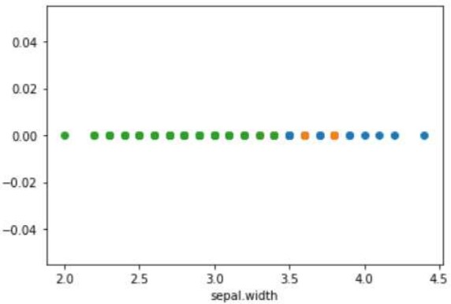

**#univariate for sepal length** df.loc[df['variety']=='Setosa'] df_Setosa=df.loc[df['variety']=='Setosa'] df_Virginica=df.loc[df['variety']=='Virginica'] df_Versicolor=df.loc[df['variety']=='Versicolor']

plt.scatter(df_Setosa['sepal.length'],np.zeros_like(df_Setosa['sepal.length'])) plt.scatter(df_Virginica['sepal.length'],np.zeros_like(df_Virginica['sepal.length'])) plt.scatter(df_Versicolor['sepal.length'],np.zeros_like(df_Versicolor['sepal.length'])) plt.xlabel('sepal.length')

plt.show()

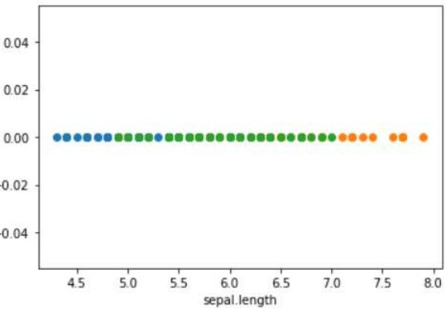

**#univariate for petal width** df.loc[df['variety']=='Setosa'] df_Setosa=df.loc[df['variety']=='Setosa'] df_Virginica=df.loc[df['variety']=='Virginica'] df_Versicolor=df.loc[df['variety']=='Versicolor']

plt.scatter(df_Setosa['petal.width'],np.zeros_like(df_Setosa['petal.width'])) plt.scatter(df_Virginica['petal.width'],np.zeros_like(df_Virginica['petal.width'])) plt.scatter(df_Versicolor['petal.width'],np.zeros_like(df_Versicolor['petal.width'])) plt.xlabel('petal.width')

plt.show()

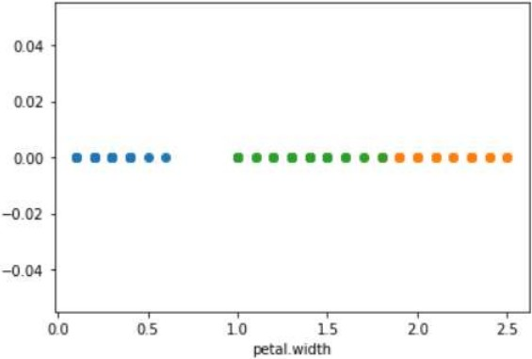

## #univariate for petal length

df.loc[df['variety']=='Setosa'] df_Setosa=df.loc[df['variety']=='Setosa'] df_Virginica=df.loc[df['variety']=='Virginica'] df_Versicolor=df.loc[df['variety']=='Versicolor']

plt.scatter(df_Setosa['petal.length'],np.zeros_like(df_Setosa['petal.length'])) plt.scatter(df_Virginica['petal.length'],np.zeros_like(df_Virginica['petal.length'])) plt.scatter(df_Versicolor['petal.length'],np.zeros_like(df_Versicolor['petal.length'])) plt.xlabel('petal.length')

plt.show()

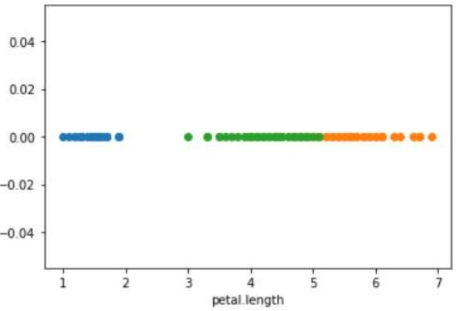Q

## #bivariate sepal.width vs petal.width

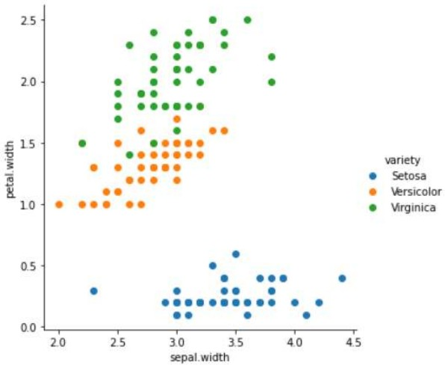sns.FacetGrid(df,hue='variety',size=5).map(plt.scatter,"sepal.width","petal.width").add_legend();

plt.show()

**#bivariate sepal.length vs petal.length** sns.FacetGrid(df,hue='variety',size=5).map(plt.scatter,"sepal.length","petal.length").add_legend(); plt.show()

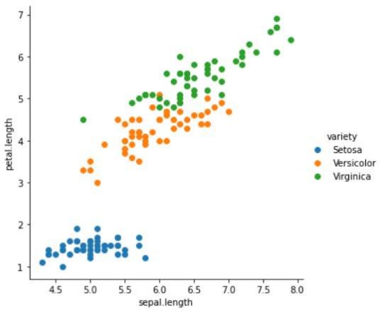

## #multivariate all the features

sns.pairplot(df,hue="variety",size=2)

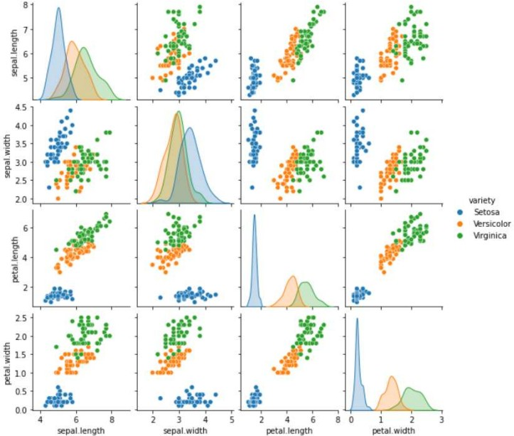

## RESULT: -

Thus, the python program to implement univariate, bivariate and multivariate regression features for the given iris dataset is analyzed and the features are plotted using scatter plot

## Ex No: 2 Date:

**A PYTHON PROGRAM TO IMPLEMENT SIMPLE LINEAR REGRESSION USING LEAST SQUARE METHOD**

**Aim***:*

To implement a python program for constructing a simple linear regression using least

square method.

## Algorithm:

Step 1: Import necessary libraries:

* + pandas for data manipulation and matplotlib.pyplot for plotting. Step 2: Read the dataset:
  + Use the pandas `read_csv` function to read the dataset (e.g., headbrain.csv).
  + Store the dataset in a variable (e.g., `data`). Step 3: Prepare the data:
  + Extract the independent variable (X) and dependent variable (y) from the dataset.
  + Reshape X and y to be 2D arrays if needed. Step 4: Calculate the mean:
  + Calculate the mean of X and y. Step 5: Calculate the coefficients:
  + Calculate the slope (m) using the formula:



* + - Calculate the intercept (b) using the formula: Step 6: Make predictions:
* Use the calculated slope and intercept to make predictions for each X value:



Step 7: Plot the regression line:

* Plot the original data points (X, y) as a scatter plot.
* Plot the regression line (X, predicted_y) as a line plot.

Step 8: Calculate the R-squared value:

* Calculate the total sum of squares (TSS) using the formula:
* Calculate the residual sum of squares (RSS) using the formula:



* Calculate the R-squared value using the formula:  Step 9: Display the results:
  + Print the slope, intercept, and R-squared value.

Step 10: Complete the program:

* Combine all the steps into a Python program.
* Run the program to perform simple linear regression on the dataset.

## PROGRAM:

import pandas as pd

import matplotlib.pyplot as plt import numpy as np

data = pd.read_csv('headbrain.csv')

x, y = np.array(list(data['Head Size(cm^3)'])), np.array(list(data['Brain Weight(grams)'])) print(x[:5], y[:5])

[4512 3738 4261 3777 4177] [1530 1297 1335 1282 1590]

def get_line(x, y):

x_m, y_m = np.mean(x), np.mean(y) print(x_m, y_m)

x_d, y_d = x-x_m, y-y_m

m = np.sum(x_d*y_d)/np.sum(x_d**2) c = y_m - (m*x_m)

print(m, c)

return lambda x : m*x+c lin = get_line(x, y)

X = np.linspace(np.min(x)-100, np.max(x)+100, 1000) Y = np.array([lin(x) for x in X])

plt.plot(X, Y, color='red', label='Regression line') plt.scatter(x, y, color='green', label='Scatter plot') plt.xlabel('Head Size(cm^3)')

plt.ylabel('Brain Weight(grams)') plt.legend()

plt.show()

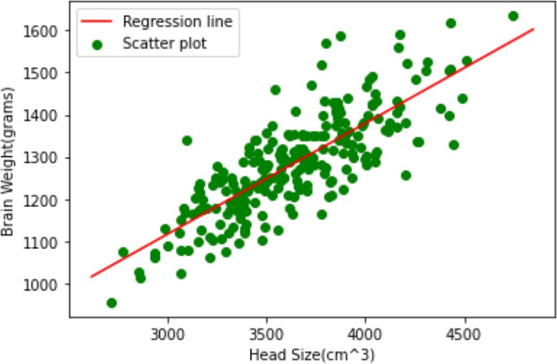

def get_error(line_fuc, x, y):

y_m = np.mean(y)

y_pred = np.array([line_fuc(_) for _ in x]) ss_t = np.sum((y-y_m)**2)

ss_r = np.sum((y-y_pred)**2) return 1-(ss_r/ss_t) get_error(lin, x, y)

## In-built Package

from sklearn.linear_model import LinearRegression x = x.reshape((len(x),1))

reg=LinearRegression() reg=reg.fit(x, y) print(reg.score(x, y))

## RESULT:

Thus, the python program to implement simple linear regression using least square method for the given head brain dataset is analyzed and the linear regression line is constructed successfully

## Ex no: 3 Date:

**A PYTHON PROGRAM TO IMPLEMENT LOGISTIC MODEL**

## Aim:

To implement python program for the logistic model using suv car dataset.

## Algorithm:

Step 1: Import Necessary Libraries:

* pandas for data manipulation
* sklearn.model_selection for train-test split
* sklearn.preprocessing for data preprocessing
* sklearn.linear_model for logistic regression
  + matplotlib.pyplot for plotting Step 2: Read the Dataset:
    - Use pandas to read the suv_cars.csv dataset into a DataFrame. Step 3: Preprocess the Data:
* Select the relevant columns for the analysis (e.g., 'Age', 'EstimatedSalary', 'Purchased').
* Encode categorical variables if necessary (e.g., using LabelEncoder or OneHotEncoder).
* Split the data into features (X) and target variable (y).

Step 4: Split the Data:

* Split the dataset into training and testing sets using train_test_split. Step 5: Feature Scaling:
* Standardize the features using StandardScaler to ensure they have the same scale. Step 6: Create and Train the Model:
* Create a logistic regression model using LogisticRegression from sklearn.linear_model.
* Train the model on the training data using the fit method.
  + Create a function named “Sigmoid ()” which will define the sigmoid values using the
  + formula (1/1+e-z) and return the computed value.
  + Create a function named “initialize()” which will initialize the values with zeroes and assign the value to “weights” variable, initializes with ones and assigns the value to variable “x” and returns both “x” and “weights”.
  + Create a function named “fit” which will be used to plot the graph according to the training data.
  + Create a predict function that will predict values according to the training model created using the fit function.
  + Invoke the standardize() function for “x-train” and “x-test” Step 7: Make Predictions:
* Use the trained model to make predictions on the test data using the predict

method.

* + Use the “predict()” function to predict the values of the testing data and assign the value to “y_pred” variable.
  + Use the “predict()” function to predict the values of the training data and assign the value to “y_trainn” variable.
  + Compute f1_score for both the training and testing data and assign the values to “f1_score_tr” and “f1_score_te” respectively

Step 8: Evaluate the Model:

* Calculate the accuracy of the model on the test data using the score method. (Accuracy = (tp+tn)/(tp+tn+fp+fn)).
* Generate a confusion matrix and classification report to further evaluate the model's performance.

Step 9: Visualize the Results:

* Plot the decision boundary of the logistic regression model (optional).

## PROGRAM :

import pandas as pd import numpy as np

from numpy import log,dot,exp,shape

from sklearn.metrics import confusion_matrix data = pd.read_csv('../input/suvcars/suv_data.csv') print(data.head())

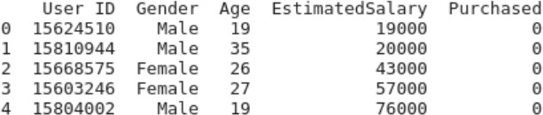

x = data.iloc[:, [2, 3]].values y = data.iloc[:, 4].values

In-built Function

from sklearn.model_selection import train_test_split

x_train, x_test, y_train, y_test=train_test_split(x,y,test_size=0.10, random_state=0) from sklearn.preprocessing import StandardScaler

sc=StandardScaler() x_train=sc.fit_transform(x_train) x_test=sc.transform(x_test)

print (x_train[0:10,:])

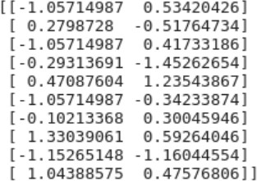

from sklearn.linear_model import LogisticRegression classifier=LogisticRegression(random_state=0) classifier.fit(x_train,y_train)

LogisticRegression (random_state=0) y_pred = classifier.predict(x_test) print(y_pred)

[000000010100000000010010100000000001001]

from sklearn.metrics import confusion_matrix cm = confusion_matrix(y_test, y_pred)

print ("Confusion Matrix : \n", cm)



from sklearn.metrics import accuracy_score

print ("Accuracy : ", accuracy_score(y_test, y_pred))



## User Defined function

from sklearn.model_selection import train_test_split

x_train, x_test, y_train, y_test=train_test_split(x,y,test_size=0.10, random_state=0)

## def Std(input_data):

mean0 = np.mean(input_data[:, 0]) sd0 = np.std(input_data[:, 0]) mean1 = np.mean(input_data[:, 1]) sd1 = np.std(input_data[:, 1])

return lambda x:((x[0]-mean0)/sd0, (x[1]-mean1)/sd1) my_std = Std(x)

my_std(x_train[0])



## def standardize(X_tr):

for i in range(shape(X_tr)[1]):

X_tr[:,i] = (X_tr[:,i] - np.mean(X_tr[:,i]))/np.std(X_tr[:,i])

## def F1_score(y,y_hat):

tp,tn,fp,fn = 0,0,0,0 for i in range(len(y)):

if y[i] == 1 and y_hat[i] == 1:

tp += 1

elif y[i] == 1 and y_hat[i] == 0:

fn += 1

elif y[i] == 0 and y_hat[i] == 1:

fp += 1

elif y[i] == 0 and y_hat[i] == 0:

tn += 1

precision = tp/(tp+fp) recall = tp/(tp+fn)

f1_score = 2*precision*recall/(precision+recall) return f1_score

## class LogisticRegression:

**def sigmoid(self,z):**

sig = 1/(1+exp(-z)) return sig

## def initialize(self,X):

weights = np.zeros((shape(X)[1]+1,1)) X = np.c_[np.ones((shape(X)[0],1)),X] return weights,X

## def fit(self,X,y,alpha=0.001,iter=400):

weights,X = self.initialize(X)

## def cost(theta):

z = dot(X,theta)

cost0 = y.T.dot(log(self.sigmoid(z)))

cost1 = (1-y).T.dot(log(1-self.sigmoid(z))) cost = -((cost1 + cost0))/len(y)

return cost

cost_list = np.zeros(iter,) for i in range(iter):

weights = weights - alpha*dot(X.T,self.sigmoid(dot(X,weights))-np.reshape(y,(len(y),1))) cost_list[i] = cost(weights)

self.weights = weights return cost_list

## def predict(self,X):

z = dot(self.initialize(X)[1],self.weights) lis = []

for i in self.sigmoid(z):

if i>0.5:

lis.append(1) else:

lis.append(0) return lis

standardize(x_train) standardize(x_test)

obj1 = ***LogisticRegression()*** model= obj1.***fit(x_train,y_train)*** y_pred = obj1.predict(x_test) y_trainn = obj1.predict(x_train)

f1_score_tr = F1_score(y_train,y_trainn) f1_score_te = F1_score(y_test,y_pred) print(f1_score_tr)

print(f1_score_te)

conf_mat = confusion_matrix(y_test, y_pred)

accuracy = (conf_mat[0, 0] + conf_mat[1, 1]) / sum(sum(conf_mat)) print("Accuracy is : ",accuracy)



## RESULT:-

Thus, the python program to implement logistic regression for the given suv_cars dataset is analyzed and the logistic regression model is classifies successfully. The performance of the developed model is measured using F1-score and Accuracy

## Ex. No.: 4

**Date:**

## A PYTHON PROGRAM TO IMPLEMENT SINGLE LAYER PERCEPTRON

**Aim:**

To implement python program for the single layer perceptron.

## Algorithm:

Step 1: Import Necessary Libraries:

* + Import numpy for numerical operations.

Step 2: Initialize the Perceptron:

* + Define the number of input features (input_dim).
  + Initialize weights (W) and bias (b) to zero or small random values.

Step 3: Define Activation Function:

* + Choose an activation function (e.g., step function, sigmoid, or ReLU).
  + User Defined function - sigmoid_func(x):

o Compute 1/(1+np.exp(-x)) and return the value.

* + User Defined function - der(x):

o Compute the product of value of sigmoid_func(x) and (1 - sigmoid_func(x) ) and return the value.

Step 4; Define Training Data:

* + Define input features (X) and corresponding target labels (y).

Step 5: Define Learning Rate and Number of Epochs:

* + Choose a learning rate (alpha) and the number of training epochs.

Step 6: Training the Perceptron:

* + For each epoch:
* For each input sample in the training data:
* Compute the weighted sum of inputs (z) as the dot product of input features and weights plus bias (z = np.dot(X[i], W) + b).
* Apply the activation function to get the predicted output (y_pred).
* Compute the error (error = y[i] - y_pred).
* Update the weights and bias using the learning rate and error (W += alpha * error * X[i]; b += alpha * error).

Step 7: Prediction:

* + Use the trained perceptron to predict the output for new input data.

Step 8: Evaluate the Model:

* Measure the performance of the model using metrics such as accuracy, precision, recall, etc.

## PROGRAM

import numpy as np import pandas as pd

input_value=np.array ([[0,0] ,[0,1], [1,1], [1,0]]) input_value.shape

## (4,2)

output = np.array([0,0,1,0]) output = output.reshape(4,1) output.shape

## #(4,1)

weights=np.array([[0.1],[0.3]]) weights

## #array ([[0.1], [0.3]])

bias = 0.2

def sigmoid_func(x):

return 1/(1+np.exp(-x)) def der(x):

return sigmoid_func(x)*(1 - sigmoid_func(x)) for epochs in range(15000):

input_arr = input_value

weighted_sum=np.dot(input_arr,weights)+bias first_output=sigmoid_func(weighted_sum) error=first_output - output

total_error=np.square(np.subtract(first_output,output)).mean() first_der=error

second_der=der(first_output) derivative=first_der*second_der t_input = input_value.T

final_derivative=np.dot(t_input,derivative) weights=weights - (0.05 * final_derivative) for i in derivative:

bias=bias-(0.05*i) print(weights) print(bias) **#[16.57299223]**

## #[16.57299223]]

**#[-25.14783487]**

pred=np.array**([1,0])**

result = np.dot(pred,weights)+bias res = sigmoid_func(result) print(res)

## #[0.00018876]

pred=np.array**([1,1])**

result = np.dot(pred,weights)+bias res = sigmoid_func(result) print(res)

## #[0.99966403]

pred=np.array**([0,0])**

result = np.dot(pred,weights)+bias res = sigmoid_func(result)

print(res)

## #[1.19793729e-11]

pred=np.array**([0,1])**

result = np.dot(pred,weights)+bias res = sigmoid_func(result) print(res)

## #[0.00063036]

**RESULT:-**

Thus, the python program to implement Single Layer Perceptron has been executed successfully.

## Ex. No.: 5

**Date:**

## A PYTHON PROGRAM TO IMPLEMENT MULTI LAYER PERCEPTRON WITH BACK PROPOGATION

**Aim:**

To implement multilayer perceptron with back propagation using python.

## Algorithm:

Step 1: Import the Necessary Libraries

* + Import pandas as pd.
  + Import numpy as np.

Step 2: Read and Display the Dataset

* + Use `pd.read_csv("banknotes.csv")` to read the dataset.
  + Assign the result to a variable (e.g., `data`).
  + Display the first ten rows using `data.head(10)`.

Step 3: Display Dataset Dimensions

* + Use the `.shape` attribute on the dataset (e.g., `data.shape`).

Step 4: Display Descriptive Statistics

* + Use the `.describe()` function on the dataset (e.g., `data.describe()`).

Step 5: Import Train-Test Split Module

* + Import `train_test_split` from `sklearn.model_selection`.

Step 6: Split Dataset with 80-20 Ratio

* + Assign the features to a variable (e.g., `X = data.drop(columns='target')`).
  + Assign the target variable to another variable (e.g., `y = data['target']`).
  + Use `train_test_split` to split the dataset into training and testing sets with a ratio of 0.2.
  + Assign the results to `x_train`, `x_test`, `y_train`, and `y_test`.

Step 7: Import MLPClassifier Module

* + Import `MLPClassifier` from `sklearn.neural_network`.

Step 8: Initialize MLPClassifier

* + Create an instance of `MLPClassifier` with `max_iter=500` and

`activation='relu'`.

* + Assign the instance to a variable (e.g., `clf`).

Step 9: Fit the Classifier

* + Fit the model using `clf.fit(x_train, y_train)`.

Step 10: Make Predictions

* + Use the `.predict()` function on `x_test` (e.g., `pred = clf.predict(x_test)`).
  + Display the predictions.

Step 11: Import Metrics Modules

* + Import `confusion_matrix` from `sklearn.metrics`.
  + Import `classification_report` from `sklearn.metrics`.

Step 12: Display Confusion Matrix

* + Use `confusion_matrix(y_test, pred)` to generate the confusion matrix.
  + Display the confusion matrix.

Step 13: Display Classification Report

* + Use `classification_report(y_test, pred)` to generate the classification report.
  + Display the classification report.

Step 14: Repeat Steps 9-13 with Different Activation Functions

* Initialize `MLPClassifier` with `activation='logistic'`.
* Fit the model and make predictions.
* Display the confusion matrix and classification report.
* Repeat for `activation='tanh'`.
* Repeat for `activation='identity'`.

Step 15: Repeat Steps 7-14 with 70-30 Ratio

* Use `train_test_split` to split the dataset into training and testing sets with a ratio of 0.3.
* Assign the results to `x_train`, `x_test`, `y_train`, and `y_test`.
* Repeat Steps 7-14 with the new training and testing sets.

## PROGRAM:

import pandas as pd import numpy as np

bnotes = pd.read_csv('../input/banknotes-dataset/bank_note_data.csv') bnotes.head(10)

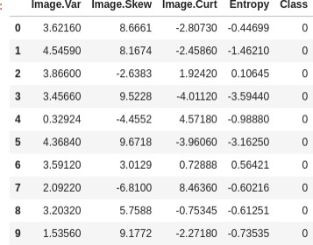

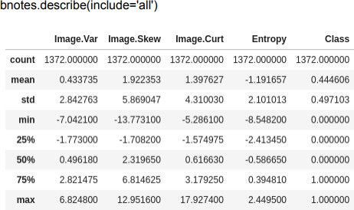

x = bnotes.drop('Class',axis=1) y = bnotes['Class'] print(x.head(2))

print(y.head(2))

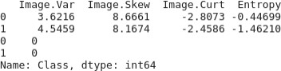

from sklearn.model_selection import train_test_split

## #train_test ratio = 0.2

x_train,x_test,y_train,y_test = train_test_split(x,y,test_size=**0.2**) from sklearn.neural_network import MLPClassifier

## # activation function : relu

mlp = MLPClassifier(max_iter=500,activation='relu') mlp.fit(x_train,y_train)

## MLPClassifier(max_iter=500)

pred = mlp.predict(x_test) print(pred)

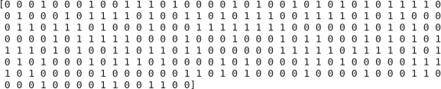

from sklearn.metrics import classification_report,confusion_matrix confusion_matrix(y_test,pred)

## array([[153, 0], [0, 122]])

print(classification_report(y_test,pred))

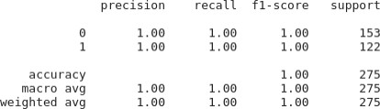

## # activation function : logistic

mlp = MLPClassifier(max_iter=500,activation='logistic') mlp.fit(x_train,y_train)

## MLPClassifier(activation='logistic', max_iter=500)

pred = mlp.predict(x_test) print(pred)

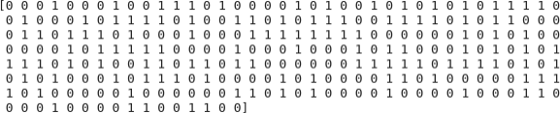

from sklearn.metrics import classification_report,confusion_matrix confusion_matrix(y_test,pred)

print(classification_report(y_test,pred))

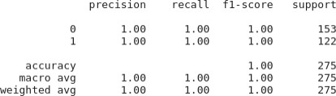

## # activation function : tanh

mlp = MLPClassifier(max_iter=500,activation='tanh') mlp.fit(x_train,y_train)

pred = mlp.predict(x_test) print(pred)

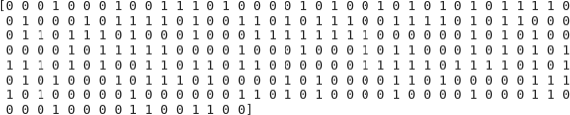

from sklearn.metrics import classification_report, confusion_matrix confusion_matrix(y_test,pred)



print(classification_report(y_test,pred))

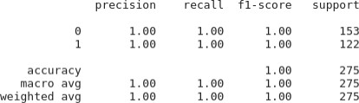

## # activation function : identity

mlp = MLPClassifier(max_iter=500,activation='identity') mlp.fit(x_train,y_train)

MLPClassifier(activation='identity', max_iter=500) pred = mlp.predict(x_test)

print(pred)

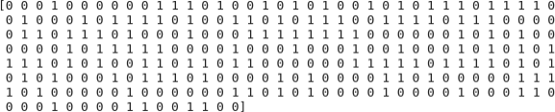

from sklearn.metrics import classification_report,confusion_matrix confusion_matrix(y_test,pred)

print(classification_report(y_test,pred))





## #train_test ratio = 0.3

x_train,x_test,y_train,y_test = train_test_split(x,y,test_size=**0.3**) from sklearn.neural_network import MLPClassifier

## # activation function : relu

mlp = MLPClassifier(max_iter=500,activation='relu') mlp.fit(x_train,y_train) MLPClassifier(max_iter=500)

pred = mlp.predict(x_test) print(pred)

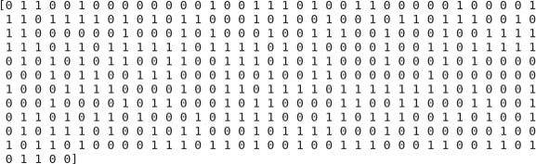

from sklearn.metrics import classification_report,confusion_matrix confusion_matrix(y_test,pred)

print(classification_report(y_test,pred))

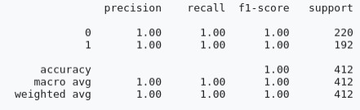

## # activation function : logistic

mlp = MLPClassifier(max_iter=500,activation='logistic') mlp.fit(x_train,y_train) MLPClassifier(max_iter=500,activation='logistic')

pred = mlp.predict(x_test) print(pred)

MLPClassifier(max_iter=500,activation='tanh')

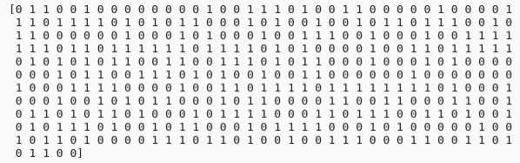

from sklearn.metrics import classification_report,confusion_matrix confusion_matrix(y_test,pred)

## # activation function : tanh

mlp = MLPClassifier(max_iter=500,activation='tanh') mlp.fit(x_train,y_train)

pred = mlp.predict(x_test) print(pred)

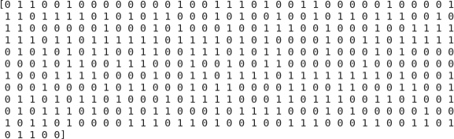

from sklearn.metrics import classification_report,confusion_matrix confusion_matrix(y_test,pred)



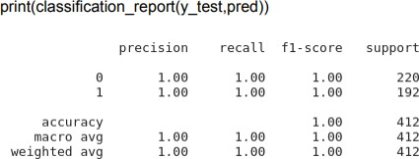

## # activation function : identity

mlp = MLPClassifier(max_iter=500,activation='identity') mlp.fit(x_train,y_train) MLPClassifier(max_iter=500,activation='identity')

pred = mlp.predict(x_test) print(pred)

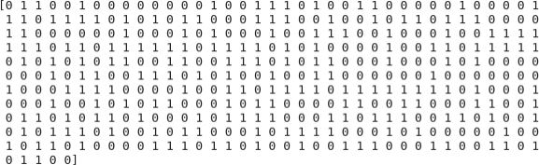

from sklearn.metrics import classification_report,confusion_matrix confusion_matrix(y_test,pred)



print(classification_report(y_test,pred))

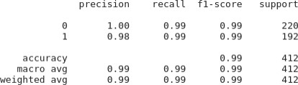

## RESULT:

Thus the python program to implement multi layer perceptron with back propagation on the given dataset(banknotes.csv) has been executed successfully and it’s results have been analyzed successfully for different activation functions(relu,logistic,tanh,identity) with two different training-testing ratios(0.2 and 0.3)

## Ex no: 6 Date:

**A PYTHON PROGRAM TO IMPLEMENT SVM CLASSIFIER MODEL**

## Aim:

To implement a SVM classifier model using python and determine its accuracy.

## Algorithm:

Step 1: Import Necessary Libraries

1. Import numpy as np.
2. Import pandas as pd.
3. Import SVM from sklearn.
4. Import matplotlib.pyplot as plt.
5. Import seaborn as sns.
6. Set the font_scale attribute to 1.2 in seaborn.

Step 2: Load and Display Dataset

1. Read the dataset (muffins.csv) using `pd.read_csv()`.
2. Display the first five instances using the `head()` function.

Step 3: Plot Initial Data

1. Use the `sns.lmplot()` function.
2. Set the x and y axes to "Sugar" and "Flour".
3. Assign "recipes" to the data parameter.
4. Assign "Type" to the hue parameter.
5. Set the palette to "Set1".
6. Set fit_reg to False.
7. Set scatter_kws to {"s": 70}.
8. Plot the graph.

Step 4: Prepare Data for SVM

1. Extract "Sugar" and "Butter" columns from the recipes dataset and assign to variable `sugar_butter`.
2. Create a new variable `type_label`.
3. For each value in the "Type" column, assign 0 if it is "Muffin" and 1 otherwise.

Step 5: Train SVM Model

1. Import the SVC module from the svm library.
2. Create an SVC model with kernel type set to linear.
3. Fit the model using `sugar_butter` and `type_label` as the parameters.

Step 6: Calculate Decision Boundary

1. Use the `model.coef_` function to get the coefficients of the linear model.
2. Assign the coefficients to a list named `w`.
3. Calculate the slope `a` as `w[0] / w[1]`.
4. Use `np.linspace()` to generate values from 5 to 30 and assign to variable `xx`.
5. Calculate the intercept using the first value of the model intercept and divide by

`w[1]`.

1. Calculate the decision boundary line `y` as `a * xx - (model.intercept_[0] / w[1])`.

Step 7: Calculate Support Vector Boundaries

1. Assign the first support vector to variable `b`.
2. Calculate `yy_down` as `a * xx + (b[1] - a * b[0])`.
3. Assign the last support vector to variable `b`.
4. Calculate `yy_up` using the same method.

Step 8: Plot Decision Boundary

1. Use the `sns.lmplot()` function again with the same parameters as in Step 3.
2. Plot the decision boundary line `xx` and `yy`.

Step 9: Plot Support Vector Boundaries

1. Plot the decision boundary with `xx`, `yy_down`, and `'k--'`.
2. Plot the support vector boundaries with `xx`, `yy_up`, and `'k--'`.
3. Scatter plot the first and last support vectors.

Step 10: Import Additional Libraries

1. Import `confusion_matrix` from `sklearn.metrics`.
2. Import `classification_report` from `sklearn.metrics`.
3. Import `train_test_split` from `sklearn.model_selection`.

Step 11: Split Dataset

1. Assign `x_train`, `x_test`, `y_train`, and `y_test` using `train_test_split`.
2. Set the test size to 0.2.

Step 12: Train New Model

1. Create a new SVC model named `model1`.
2. Fit the model using the training data (`x_train` and `y_train`).

Step 13: Make Predictions

1. Use the `predict()` function on `model1` with `x_test` as the parameter.
2. Assign the predictions to variable `pred`.

Step 14: Evaluate Model

1. Display the confusion matrix.
2. Display the classification report.

## PROGRAM:

import numpy as np import pandas as pd from sklearn import svm

import matplotlib.pyplot as plt

import seaborn as sns; sns.set(font_scale=1.2) recipes=pd.read_csv('../input/muffins-datset/recipes_muffins_cupcakes.csv') recipes.head()

recipes.shape



sns.lmplot('Sugar','Flour',data=recipes,hue='Type',palette='Set1',fit_reg=False,sc atter_kws={"s":70})

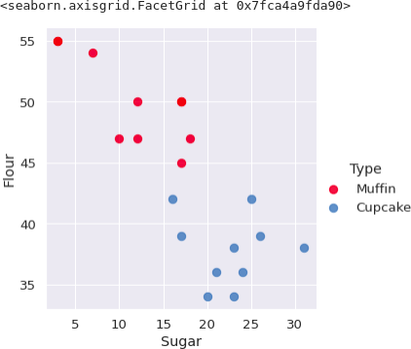

sugar_butter=recipes[['Sugar','Flour']].values type_label=np.where(recipes['Type']=='Muffin',0,1) model=svm.SVC(kernel='linear') model.fit(sugar_butter,type_label SVC(kernel='linear')

w=model.coef_[0] #seperating the hyperplane a=-w[0]/w[1]

xx=np.linspace(5,30)

yy=a*xx-(model.intercept_[0]/w[1])

b=model.support_vectors_[0] #plot to seperate hyperplane that pass

yy_down=a*xx+(b[1]-a*b[0]) b=model.support_vectors_[-1] yy_up=a*xx+(b[1]-a*b[0])

sns.lmplot('Sugar','Flour',data=recipes,hue='Type',palette='Set1',fit_reg=False,sc atter_kws={"s":70})

plt.plot(xx,yy,linewidth=2,color='black')

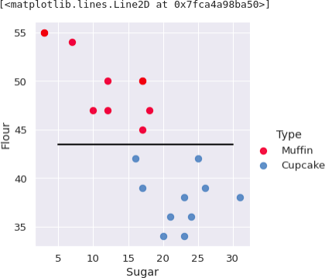

scatterkws={"s":70}) plt.plot(xx,yy,linewidth=2,color='black')

sns.lmplot('Sugar','Flour',data=recipes,hue='Type',palette='Set1',fit_reg=False,sc atter_kws={"s":70})

plt.plot(xx,yy,linewidth=2,color='black') plt.plot(xx,yy_down,'k--')

plt.plot(xx,yy_up,'k--') plt.scatter(model.support_vectors_[:,0],model.support_vectors_[:,-1],s=80,facecol or='none')

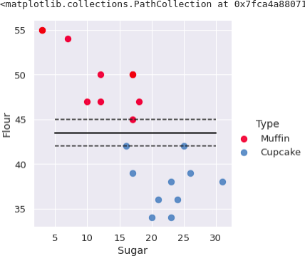

from sklearn.metrics import confusion_matrix

from sklearn.model_selection import train_test_split from sklearn.metrics import classification_report x_train,x_test,y_train,y_test = train_test_split(sugar_butter,type_label,test_size=0.2) model1=svm.SVC(kernel='linear') model1.fit(x_train,y_train)

pred = model1.predict(x_test) print(pred)



print(confusion_matrix(y_test,pred))



print(classification_report(y_test,pred))

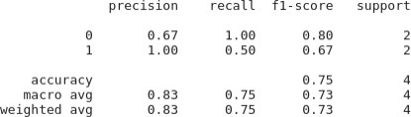

## RESULT:

Thus the python program to implement SVM classifier model has been executed successfully and the classified output has been analyzed for the given dataset(muffins.csv)

## Ex. No.: 7

**Date:**

## A PYTHON PROGRAM TO IMPLEMENT DECISION TREE

**Aim:**

To implement a decision tree using a python program for the given dataset and plot

the trained decision tree.

## Algorithm:

Step 1: Import the Iris Dataset

1. Import `load_iris` from `sklearn.datasets`.

Step 2: Import Necessary Libraries

1. Import numpy as np.
2. Import matplotlib.pyplot as plt.
3. Import `DecisionTreeClassifier` from `sklearn.tree`.

Step 3: Declare and Initialize Parameters

1. Declare and initialize `n_classes = 3`.
2. Declare and initialize `plot_colors = "ryb"`.
3. Declare and initialize `plot_step = 0.02`.

Step 4: Prepare Data for Model Training

1. Load the iris dataset using `load_iris()`.
2. Assign the dataset's data to variable `X`.
3. Assign the dataset's target to variable `Y`.

Step 5: Train the Model

1. Create an instance of `DecisionTreeClassifier`.
2. Fit the classifier using `clf.fit(X, Y)`.

Step 6: Initialize Pair Index and Plot Graph

1. Loop through each pair of features using `for pairidx, pair in enumerate(combinations (range(X.shape[1]), 2)):`
2. Inside the loop, assign `X` with the selected pair of features (e.g., `X = iris.data[:, pair]`).
3. Assign `Y` with the target list (e.g., `Y = iris.target`).

Step 7: Assign Axis Limits

* 1. Inside the loop, assign `x_min` with the minimum value of the selected feature minus 1 (e.g., `x_min, x_max = X[:, 0].min() - 1, X[:, 0].max() + 1`).
  2. Assign `x_max` with the maximum value of the selected feature plus 1.
  3. Assign `y_min` with the minimum value of the second selected feature minus 1 (e.g., `y_min, y_max = X[:, 1].min() - 1, X[:, 1].max() + 1`).
  4. Assign `y_max` with the maximum value of the second selected feature plus 1.

Step 8: Create Meshgrid

1. Use `np.meshgrid` to create a grid of values from `x_min` to `x_max` and `y_min` to `y_max` with steps of `plot_step`.
2. Assign the results to variables `xx` and `yy`.

Step 9: Plot Graph with Tight Layout

1. Use `plt.tight_layout()` to adjust the layout of the plots.

2. Set `h_pad=0.5`, `w_pad=0.5`, and `pad=2.5`.

Step 10: Predict and Reshape

1. Use the classifier to predict on the meshgrid (e.g., `Z = clf.predict(np.c_[xx.ravel(), yy.ravel()])`).
2. Reshape `Z` to the shape of `xx`.

Step 11: Plot Decision Boundary

1. Use `plt.contourf(xx, yy, Z, cmap=plt.cm.RdYlBu)` to plot the decision boundary with the "RdYlBu" color scheme.

Step 12: Plot Feature Pairs

1. Inside the loop, label the x-axis and y-axis with the feature names (e.g.,

`plt.xlabel(iris.feature_names[pair[0]])` and `plt.ylabel(iris.feature_names[pair[1]])`).

Step 13: Plot Training Points

1. Use `plt.scatter(X[:, 0], X[:, 1], c=Y, cmap=plt.cm.RdYlBu, edgecolor='k', s=15)` to plot the training points with the "RdYlBu" color scheme, black edge color, and size 15.

Step 14: Plot Final Decision Tree

1. Set the title of the plot to "Decision tree trained on all the iris features" (e.g.,

`plt.title("Decision tree trained on all the iris features")`).

1. Display the plot using `plt.show()`.

## PROGRAM:

from sklearn.datasets import load_iris iris = load_iris()

import numpy as np

import matplotlib.pyplot as plt

from sklearn.tree import DecisionTreeClassifier # Parameters

n_classes = 3 plot_colors = "ryb" plot_step = 0.02

for pairidx, pair in enumerate([[0, 1], [0, 2], [0, 3], [1, 2], [1, 3], [2, 3]]): # We only take the two corresponding features

X = iris.data[:, pair] y = iris.target

# Train

clf = DecisionTreeClassifier().fit(X, y) # Plot the decision boundary plt.subplot(2, 3, pairidx + 1)

x_min, x_max = X[:, 0].min() - 1, X[:, 0].max() + 1

y_min, y_max = X[:, 1].min() - 1, X[:, 1].max() + 1 xx, yy = np.meshgrid(

np.arange(x_min, x_max, plot_step), np.arange(y_min, y_max, plot_step)

)

plt.tight_layout(h_pad=0.5, w_pad=0.5, pad=2.5) Z = clf.predict(np.c_[xx.ravel(), yy.ravel()])

Z = Z.reshape(xx.shape)

cs = plt.contourf(xx, yy, Z, cmap=plt.cm.RdYlBu) plt.xlabel(iris.feature_names[pair[0]]) plt.ylabel(iris.feature_names[pair[1]])

# Plot the training points

for i, color in zip(range(n_classes), plot_colors):

idx = np.where(y == i) plt.scatter(

X[idx, 0],

X[idx, 1], c=color,

label=iris.target_names[i], cmap=plt.cm.RdYlBu, edgecolor="black",

s=15)

plt.suptitle("Decision surface of decision trees trained on pairs of features") plt.legend(loc="lower right", borderpad=0, handletextpad=0) plt.axis("tight")

from sklearn.tree import plot_tree plt.figure()

clf = DecisionTreeClassifier().fit(iris.data,iris.target) plot_tree(clf, filled=True)

plt.title("Decision tree trained on all the iris features") plt.show()

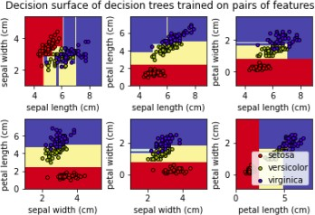

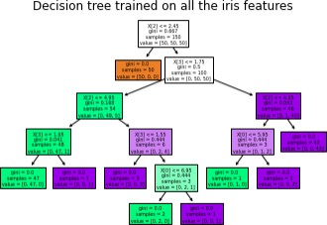

## RESULT:

Thus the python program to implement Decision Tree for the given dataset has been successfully implemented and the results have been verified and analyzed

## Ex. No.: 8 a.

**Date:**

# A PYTHON PROGRAM TO IMPLEMENT ADA BOOSTING

## Aim:

To implement a python program for Ada Boosting.

## Algorithm:

Step 1: Import Necessary Libraries Import numpy as np.

Import pandas as pd.

Import DecisionTreeClassifier from sklearn.tree. Import train_test_split from sklearn.model_selection. Import accuracy_score from sklearn.metrics.

Step 2: Load and Prepare Data

Load your dataset using pd.read_csv() (e.g., df = pd.read_csv('data.csv')). Separate features (X) and target (y).

Split the dataset into training and testing sets using train_test_split().

Step 3: Initialize Parameters

Set the number of weak classifiers n_estimators.

Initialize an array weights for instance weights, setting each weight to 1 / number_of_samples.

Step 4: Train Weak Classifiers

Loop for n_estimators iterations:

Train a weak classifier using DecisionTreeClassifier(max_depth=1) on the training data weighted by weights.

Predict the target values using the trained weak classifier.

Calculate the error rate err as the sum of weights of misclassified samples divided by the sum of all weights.

Compute the classifier's weight alpha using 0.5 * np.log((1 - err) / err).

Update the weights: multiply the weights of misclassified samples by np.exp(alpha) and the weights of correctly classified samples by np.exp(-alpha).

Normalize the weights so that they sum to 1.

Append the trained classifier and its weight to lists classifiers and alphas.

Step 5: Make Predictions

For each sample in the testing set:

Initialize a prediction score to 0.

For each trained classifier and its weight:

Add the classifier's prediction (multiplied by its weight) to the prediction score. Take the sign of the prediction score as the final prediction.

Step 6: Evaluate the Model

Compute the accuracy of the AdaBoost model on the testing set using accuracy_score().

Step 7: Output Results

Print or plot the final accuracy and possibly other evaluation metrics.

## PROGRAM:

import pandas as pd import numpy as np

from mlxtend.plotting import plot_decision_regions df = pd.DataFrame()

df['X1']=[1,2,3,4,5,6,6,7,9,9]

df['X2']=[5,3,6,8,1,9,5,8,9,2]

df['label']=[1,1,0,1,0,1,0,1,0,0]

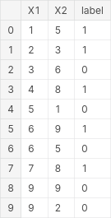

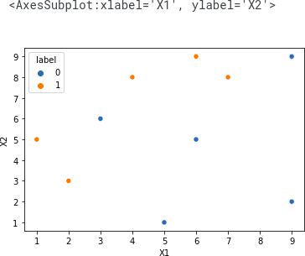import seaborn as sns sns.scatterplot(x=df['X1'],y=df['X2'],hue=df['label'])

df['weights']=1/df.shape[0]

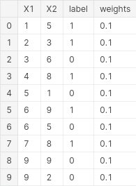

from sklearn.tree import DecisionTreeClassifier

dt1 = DecisionTreeClassifier(max_depth=1) x = df.iloc[:,0:2].values

y = df.iloc[:,2].values

# Step 2 - Train 1st Model dt1.fit(x,y)

from sklearn.tree import plot_tree

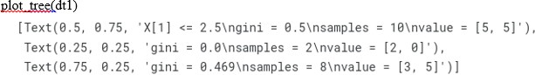

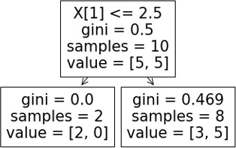

## plot_decision_regions (x,yclf=dt1, legend=2)

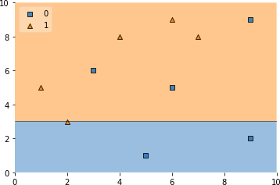

dfl'y pred'] = dt1.predict(x)

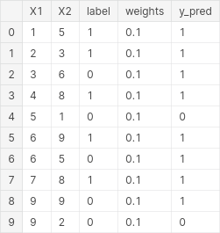

def calculate_model_weight(error): return 0.5*np.log((1-error)/(error))

# Step - 3 Calculate model weight alpha1 = calculate_model_weight(0.3) alpha1

## 0.42364893019360184

# Step -4 Update weights

def update_row_weights(row,alpha=0.423): if row['label'] == row['y_pred']:

return row['weights']* np.exp(-alpha) else:

return row['weights']* np.exp(alpha)

df['updated_weights'] = df.apply(update_row_weights,axis=1)

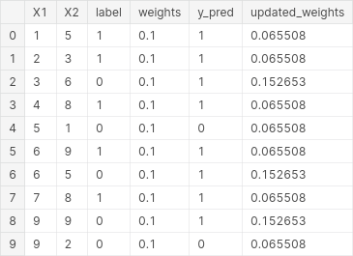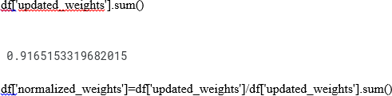

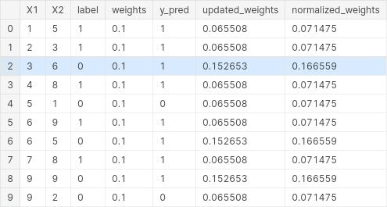

df['normalized_weights'].sum()



df['cumsum_upper'] = np.cumsum(df['normalized_weights']) df['cumsum_lower']=df['cumsum_upper'] - df['normalized_weights'] df[['X1','X2','label','weights','y_pred','updated_weights','cumsum_lower','cumsum

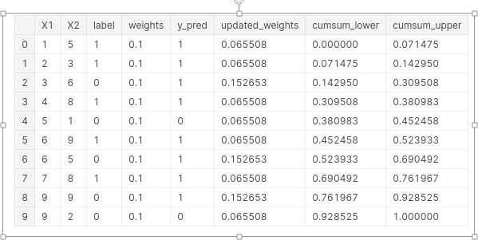

def create_new_dataset(df): indices= []

for i in range(df.shape[0]): a = np.random.random()

for index,row in df.iterrows():

if row['cumsum_upper']>a and a>row['cumsum_lower']: indices.append(index)

return indices

index_values = create_new_dataset(df) index_values



second_df = df.iloc[index_values,[0,1,2,3]] second_df

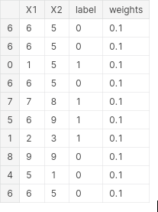

dt2 = DecisionTreeClassifier(max_depth=1)

x = second_df.iloc[:,0:2].values y = second_df.iloc[:,2].values

dt2.fit(x,y)



plot_tree(dt2)

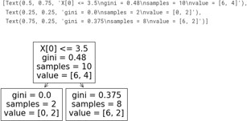

plot_decision_regions(x, y, clf=dt2, legend=2)

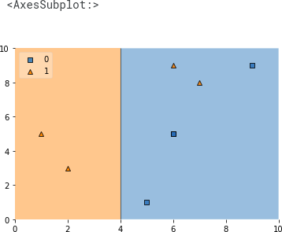

second_df['y_pred'] = dt2.predict(x) second_df

alpha2 = calculate_model_weight(0.1)

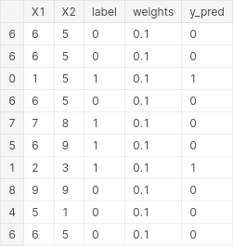

alpha2



## # Step 4 - Update weights

def update_row_weights(row,alpha=1.09): if row['label'] == row['y_pred']:

return row['weights'] * np.exp(-alpha) else:

return row['weights'] * np.exp(alpha)

second_df['updated_weights'] = second_df.apply(update_row_weights,axis=1) second_df

second_df['nomalized_weights'].sum()

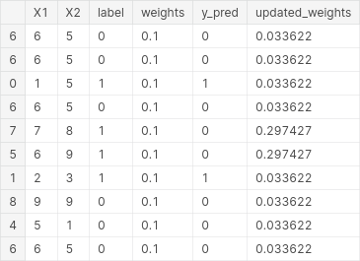

second_df['nomalized_weights'].sum()



second_df['cumsum_upper'] = np.cumsum(second_df['nomalized_weights'])

second_df['cumsum_lower'] = second_df['cumsum_upper'] - second_df['nomalized_weights'] second_df[['X1','X2','label','weights','y_pred','nomalized_weights','cumsum_lower','cumsum_ upper']]

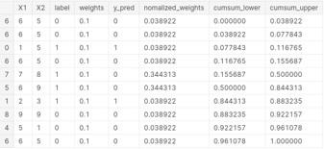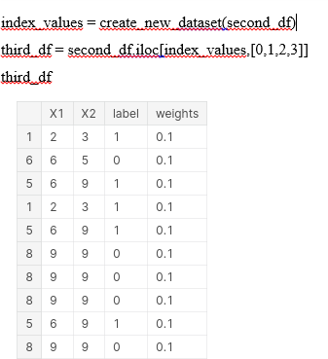

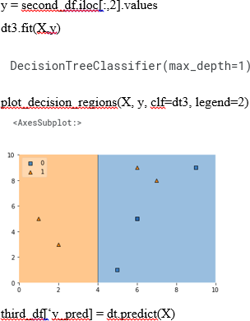

alpha3 = calculate_model_weight(0.7) alpha3



print(alpha1,alpha2,alpha3)



query = np.array([1,5]).reshape(1,2) dt1.predict(query)

dt2.predict(query)



dt3.predict(query)



alpha1*1 + alpha2*(1) + alpha3*(1)



np.sign(1.09)



query = np.array([9,9]).reshape(1,2) dt1.predict(query)



dt2.predict(query)



dt3.predict(query)



alpha1*(1) + alpha2*(-1) + alpha3*(-1)



np.sign(-0.25)



## RESULT:

Thus the python program to implement Adaboosting has been executed successfully and the results have been verified and analyzed.

**Ex. No.: 8b Date:**

# A PYTHON PROGRAM TO IMPLEMENT GRADIENT BOOSTING

## Aim:

To implement a python program using the gradient boosting model.

## Algorithm:

Step 1: Import Necessary Libraries Import numpy as np.

Import pandas as pd.

Import train_test_split from sklearn.model_selection. Import DecisionTreeRegressor from sklearn.tree.

Import mean_squared_error from sklearn.metrics.

Step 2: Prepare the Data

Load your dataset into a DataFrame using pd.read_csv('your_dataset.csv'). Split the dataset into features (X) and target (y).

Use train_test_split to split the data into training and testing sets.

Step 3: Initialize Parameters

Set the number of boosting rounds (e.g., n_estimators = 100). Set the learning rate (e.g., learning_rate = 0.1).

Initialize an empty list to store the weak learners (decision trees). Initialize an empty list to store the learning rates for each round.

Step 4: Initialize the Base Model

Compute the initial prediction as the mean of the target values (e.g., F0 = np.mean(y_train)).

Initialize the predictions to the base model's prediction (e.g., F = np.full(y_train.shape, F0)).

Step 5: Iterate Over Boosting Rounds For each boosting round:

Compute the pseudo-residuals (negative gradient of the loss function) (e.g., residuals

= y_train - F).

Fit a decision tree to the pseudo-residuals.

Make predictions using the fitted tree (e.g., tree_predictions = tree.predict(X_train)). Update the predictions by adding the learning rate multiplied by the tree predictions (e.g., F += learning_rate * tree_predictions).

Append the fitted tree and the learning rate to their respective lists.

Step 6: Make Predictions on Test Data

Initialize the test predictions with the base model's prediction (e.g., F_test = np.full(y_test.shape, F0)).

For each fitted tree and its learning rate:

Make predictions on the test data using the fitted tree.

Update the test predictions by adding the learning rate multiplied by the tree predictions.

Step 7: Evaluate the Model

Compute the mean squared error on the training data. Compute the mean squared error on the test data.

## PROGRAM:

import numpy as np

import matplotlib.pyplot as plt import pandas as pd

np.random.seed(42)

X = np.random.rand(100, 1) - 0.5

y = 3*X[:, 0]**2 + 0.05 * np.random.randn(100) df = pd.DataFrame()

df['X'] = X.reshape(100)

df['y'] = y

df

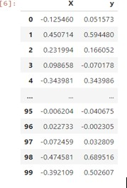

plt.scatter(df['X'],df['y']) plt.title('X vs y')

Text(0.5, 1.0, 'X vs y')

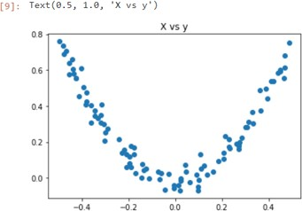

df['pred1'] = df['y'].mean() df

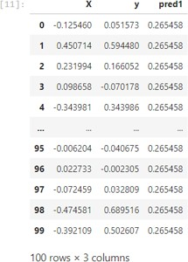

df['res1'] = df['y'] - df['pred1'] df

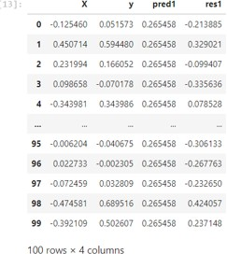

plt.scatter(df['X'],df['y'])

plt.plot(df['X'],df['pred1'],color='red')

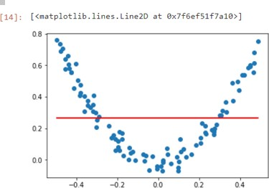

from sklearn.tree import DecisionTreeRegressor tree1 = DecisionTreeRegressor(max_leaf_nodes=8)

tree1.fit(df['X'].values.reshape(100,1),df['res1'].values) DecisionTreeRegressor(max_leaf_nodes=8)

from sklearn.tree import plot_tree plot_tree(tree1)

plt.show()

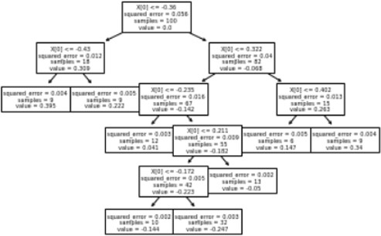

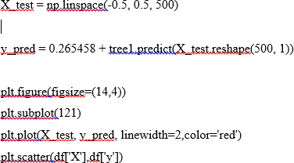

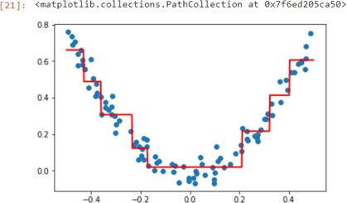

df['pred2'] = 0.265458 + tree1.predict(df['X'].values.reshape(100,1)) df

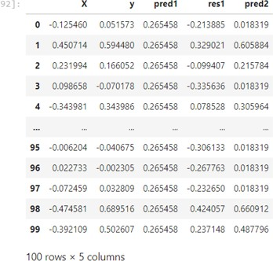

df['res2'] = df['y'] - df['pred2'] df

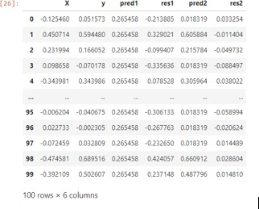

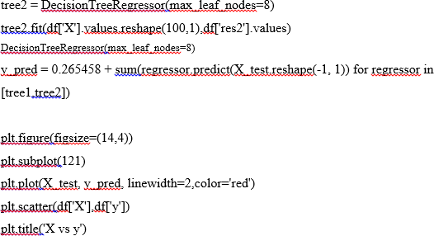

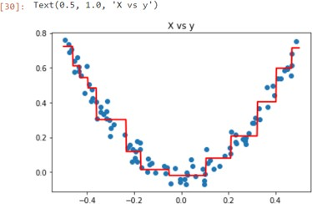

def gradient_boost(X,y,number,lr,count=1,regs=[],foo=None): if number == 0:

return else:

# do gradient boosting if count > 1:

y = y - regs[-1].predict(X) else:

foo = y

tree_reg = DecisionTreeRegressor(max_depth=5, random_state=42) tree_reg.fit(X, y)

regs.append(tree_reg)

x1 = np.linspace(-0.5, 0.5, 500)

y_pred = sum(lr * regressor.predict(x1.reshape(-1, 1)) for regressor in regs)

print(number) plt.figure()

plt.plot(x1, y_pred, linewidth=2) plt.plot(X[:, 0], foo,"r") plt.show()

gradient_boost(X,y,number-1,lr,count+1,regs,foo=foo)

np.random.seed(42)

X = np.random.rand(100, 1) - 0.5

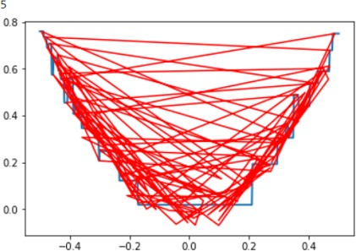y = 3*X[:, 0]**2 + 0.05 * np.random.randn(100) gradient_boost(X,y,5,lr=1)

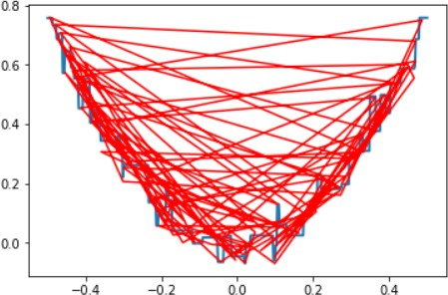

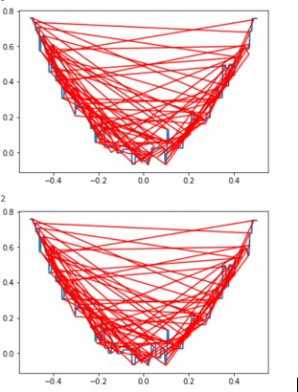

## RESULT:

Thus, the python program to implement gradient boosting for the standard uniform distribution has been successfully implemented and the results have been verified and analyzed.

**Ex. No.: 9 a. Date:**

# A PYTHON PROGRAM TO IMPLEMENT KNN MODEL

## Aim:

To implement a python program using a KNN Algorithm in a model.

## Algorithm:

1. Import Necessary Libraries
   * Import necessary libraries: pandas, numpy, train_test_split from sklearn.model_selection, StandardScaler from sklearn.preprocessing, KNeighborsClassifier from sklearn.neighbors, and classification_report and confusion_matrix from sklearn.metrics.
2. Load and Explore the Dataset
   * Load the dataset using pandas.
   * Display the first few rows of the dataset using df.head().
   * Display the dimensions of the dataset using df.shape().
   * Display the descriptive statistics of the dataset using df.describe().
3. Preprocess the Data
   * Separate the features (X) and the target variable (y).
   * Split the data into training and testing sets using train_test_split.
   * Standardize the features using StandardScaler.
4. Train the KNN Model
   * Create an instance of KNeighborsClassifier with a specified number of neighbors (k).
   * For each data point, calculate the Euclidean distance to all other data points.
   * Select the K nearest neighbors based on the calculated Euclidean distances.
   * Among the K nearest neighbors, count the number of data points in each category.
   * Assign the new data point to the category for which the number of neighbors is maximum.
5. Make Predictions
   * Use the trained model to make predictions on the test data.
   * Evaluate the Model
   * Generate the confusion matrix and classification report using the actual and predicted values.
   * Print the confusion matrix and classification report.

import numpy as np

import matplotlib.pyplot as plt import pandas as pd

dataset = pd.read_csv('../input/mall-customers/Mall_Customers.csv')

X = dataset.iloc[:,[3,4]].values print(dataset)

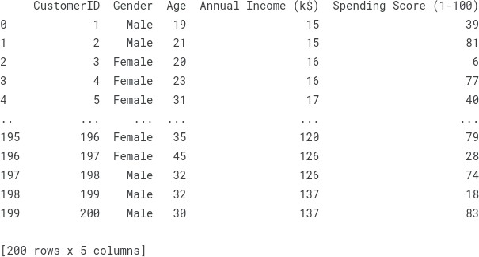

from sklearn.cluster import KMeans wcss =[]

for i in range (1,11):

kmeans = KMeans(n_clusters = i, init = 'k-means++', max_iter =300, n_init = 10, random_state = 0)

kmeans.fit(X) wcss.append(kmeans.inertia_)

# Plot the graph to visualize the Elbow Method to find the optimal number of cluster plt.plot(range(1,11),wcss)

plt.title('The Elbow Method') plt.xlabel('Number of clusters') plt.ylabel('WCSS')

plt.show()

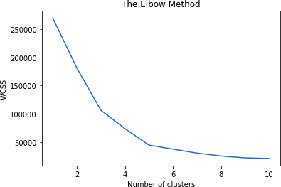

kmeans=KMeans(n_clusters= 5, init = 'k-means++', max_iter = 300, n_init = 10, random_state = 0)

y_kmeans = kmeans.fit_predict(X) y_kmeans

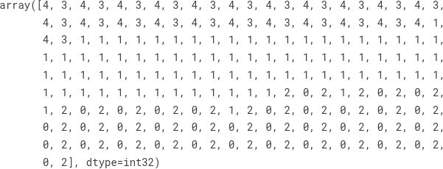

type(y_kmeans)



y_kmeans

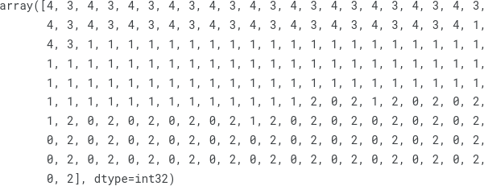

plt.scatter(X[y_kmeans == 0, 0], X[y_kmeans == 0, 1], s = 100, c = 'red', label = 'Cluster 1')

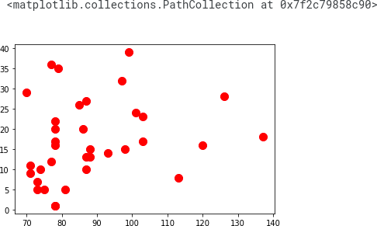

plt.scatter(X[y_kmeans == 1, 0], X[y_kmeans == 1, 1], s = 100, c = 'blue', label = 'Cluster 2')

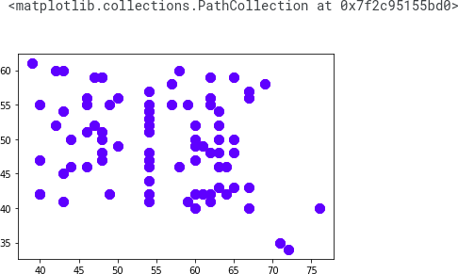

plt.scatter(X[y_kmeans == 2, 0], X[y_kmeans == 2, 1], s = 100, c = 'green', label = 'Cluster 3')

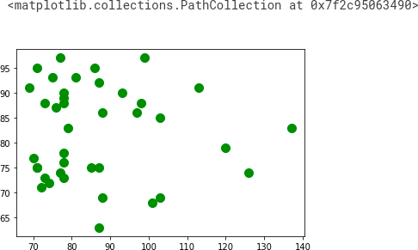

plt.scatter(X[y_kmeans == 3, 0], X[y_kmeans == 3, 1], s = 100, c = 'cyan', label = 'Cluster 4')

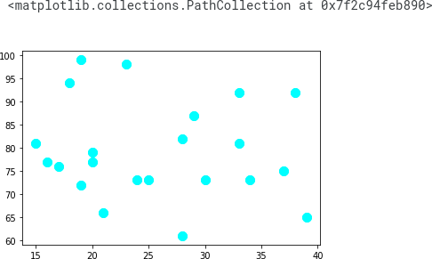

plt.scatter(X[y_kmeans == 4, 0], X[y_kmeans == 4, 1], s = 100, c = 'magenta', label =

'Cluster 5')

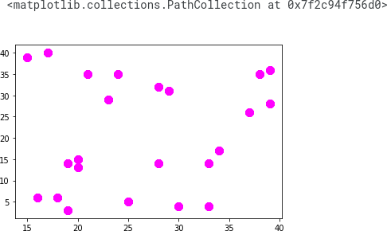

plt.scatter(kmeans.cluster_centers_[:, 0], kmeans.cluster_centers_[:, 1], s = 300, c = 'yellow', label = 'Centroids')

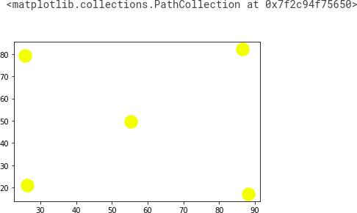

plt.title('Clusters of customers') plt.xlabel('Annual Income (k$)') plt.ylabel('Spending Score (1-100)') plt.legend()

plt.show()

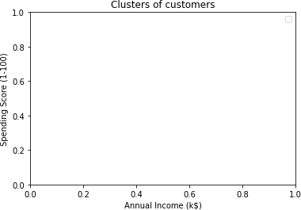

plt.scatter(X[y_kmeans == 0, 0], X[y_kmeans == 0, 1], s = 100, c = 'red', label = 'Cluster 1')

plt.scatter(X[y_kmeans == 1, 0], X[y_kmeans == 1, 1], s = 100, c = 'blue', label = 'Cluster 2') plt.scatter(X[y_kmeans == 2, 0], X[y_kmeans == 2, 1], s = 100, c = 'green', label = 'Cluster 3')

plt.scatter(X[y_kmeans == 3, 0], X[y_kmeans == 3, 1], s = 100, c = 'cyan', label = 'Cluster 4')

plt.scatter(X[y_kmeans == 4, 0], X[y_kmeans == 4, 1], s = 100, c = 'magenta', label =

'Cluster 5')

plt.scatter(kmeans.cluster_centers_[:, 0], kmeans.cluster_centers_[:, 1], s = 300, c = 'yellow', label = 'Centroids')

plt.title('Clusters of customers') plt.xlabel('Annual Income (k$)') plt.ylabel('Spending Score (1-100)') plt.legend()

plt.show()

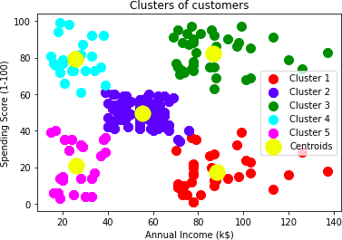

## RESULT:-

Thus the python program to implement KNN model has been successfully implemented and the results have been verified and analyzed.

## Ex. No.: 9 b.

**Date:**

## A PYTHON PROGRAM TO IMPLEMENT K-MEANS MODEL

**Aim:**

To implement a python program using a K-Means Algorithm in a model.

## Algorithm:

1. Import Necessary Libraries:

Import required libraries like numpy, matplotlib.pyplot, and sklearn.cluster.

1. Load and Preprocess Data: Load the dataset.

Preprocess the data if needed (e.g., scaling).

1. Initialize Cluster Centers:

Choose the number of clusters (K). Initialize K cluster centers randomly.

1. Assign Data Points to Clusters:

For each data point, calculate the distance to each cluster center. Assign the data point to the cluster with the nearest center.

1. Update Cluster Centers:

Calculate the mean of the data points in each cluster. Update the cluster centers to the calculated means.

1. Repeat Steps 4 and 5:

Repeat the assignment of data points to clusters and updating of cluster centers until convergence (i.e., when the cluster assignments do not change much between iterations).

1. Plot the Clusters:

Plot the data points and the cluster centers to visualize the clustering result.

## PROGRAM:

data = pd.read_csv('../input/k-means-clustering/KNN (3).csv') data.head(5)

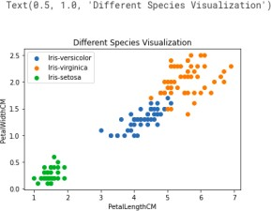

req_data = data.iloc[:,1:] req_data.head(5)

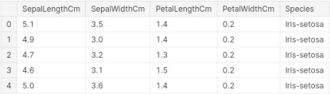

shuffle_index = np.random.permutation(req_data.shape[0]) #shuffling the row index of our dataset

req_data = req_data.iloc[shuffle_index] req_data.head(5)

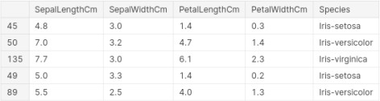

train_size = int(req_data.shape[0]*0.7) train_df = req_data.iloc[:train_size,:] test_df = req_data.iloc[train_size:,:] train = train_df.values

test = test_df.values y_true = test[:,-1]

print('Train_Shape: ',train_df.shape) print('Test_Shape: ',test_df.shape)



from math import sqrt

def euclidean_distance(x_test, x_train): distance = 0

for i in range(len(x_test)-1):

distance += (x_test[i]-x_train[i])**2 return sqrt(distance)

def get_neighbors(x_test, x_train, num_neighbors): distances = []

data = []

for i in x_train: distances.append(euclidean_distance(x_test,i)) data.append(i)

distances = np.array(distances) data = np.array(data)

sort_indexes = distances.argsort() #argsort() function returns indices by sorting distances data in ascending order

data = data[sort_indexes] #modifying our data based on sorted indices, so that we can get the nearest neighbors

return data[:num_neighbors]

def prediction(x_test, x_train, num_neighbors):

classes = []

neighbors = get_neighbors(x_test, x_train, num_neighbors) for i in neighbors:

classes.append(i[-1])

predicted = max(classes, key=classes.count) #taking the most repeated class return predicted

def predict_classifier(x_test):

classes = []

neighbors = get_neighbors(x_test, req_data.values, 5) for i in neighbors:

classes.append(i[-1])

predicted = max(classes, key=classes.count) print(predicted)

return predicted

def accuracy(y_true, y_pred): num_correct = 0

for i in range(len(y_true)):

if y_true[i]==y_pred[i]: num_correct+=1

accuracy = num_correct/len(y_true) return accuracy

y_pred = [] for i in test:

y_pred.append(prediction(i, train, 5)) y_pred

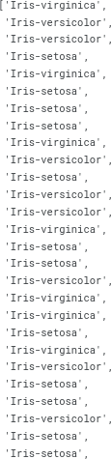

accuracy = accuracy(y_true, y_pred) accuracy



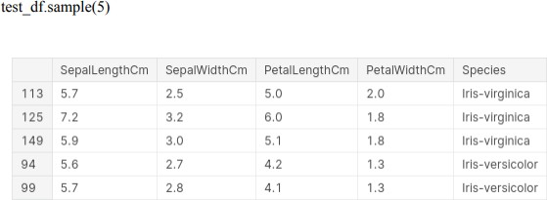

## RESULT:-

Thus the python program to implement the K-Means model has been successfully implemented and the results have been verified and analyzed

## Ex. No.: 10

**Date:**

## A PYTHON PROGRAM TO IMPLEMENT DIMENSIONALITY REDUCTION USING PCA

**Aim:**

To implement Dimensionality Reduction using PCA in a python program.

## Algorithm:

Step 1: Import Libraries

Import necessary libraries, including pandas, numpy, matplotlib.pyplot, and sklearn.decomposition.PCA.

Step 2: Load the Dataset (iris dataset)

Load your dataset into a pandas DataFrame.

Step 3: Standardize the Data

Standardize the features of the dataset using StandardScaler from sklearn.preprocessing.

Step 4: Apply PCA

* Create an instance of PCA with the desired number of components.
* Fit PCA to the standardized data.
* Transform the data to its principal components using transform. Step 5: Explained Variance Ratio
* Calculate the explained variance ratio for each principal component.
* Plot a scree plot to visualize the explained variance ratio. Step 6: Choose the Number of Components

Based on the scree plot, choose the number of principal components that explain a significant amount of variance.

Step 7: Apply PCA with Chosen Components

Apply PCA again with the chosen number of components.

Step 8: Visualize the Reduced Data

* Transform the original data to the reduced dimension using the fitted PCA.
* Visualize the reduced data using a scatter plot.

Step 9: Interpretation

Interpret the results, considering the trade-offs between dimensionality reduction and information loss.

## PROGRAM:

from sklearn import datasets import pandas as pd

from sklearn.preprocessing import StandardScaler from sklearn.decomposition import PCA

import seaborn as sns iris = datasets.load_iris()

df = pd.DataFrame(iris['data'], columns = iris['feature_names']) df.head()

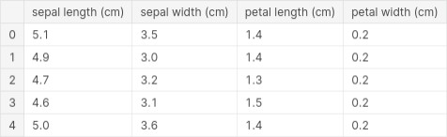

scalar = StandardScaler()

scaled_data = pd.DataFrame(scalar.fit_transform(df)) #scaling the data scaled_data

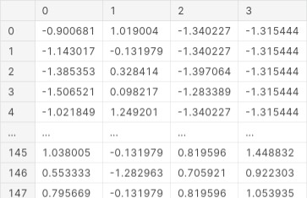

6

sns.heatmap(scaled_data.corr())

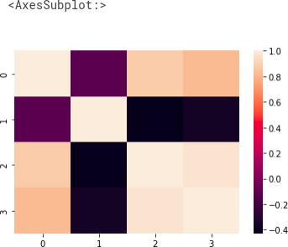

pca = PCA(n_components = 3) pca.fit(scaled_data)

data_pca = pca.transform(scaled_data)

data_pca = pd.DataFrame(data_pca,columns=['PC1','PC2','PC3']) data_pca.head()

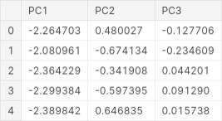

sns.heatmap(data_pca.corr())

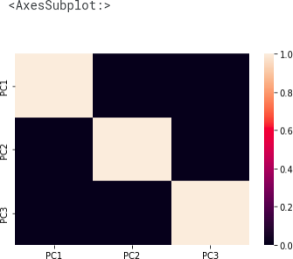

## RESULT:-

Thus Dimensionality Reduction has been implemented using PCA in a python program successfully and the results have been analyzed

## VIVA QUESTIONS

1. What is the primary goal of univariate regression?

To model the relationship between a single predictor variable and a response variable.

1. In bivariate regression, how many predictor variables are used? One predictor variable.
2. Which type of regression analysis would you use to analyze the relationship between multiple predictor variables and a single response variable?

Multivariate regression.

1. What is the equation of a simple linear regression model?



1. Which method is commonly used to estimate the coefficients in linear regression? Least squares method.
2. In multivariate regression, what does the term represent? The coefficient for the jth predictor variable.
3. Which of the following is a key assumption of linear regression? Linearity, independence, homoscedasticity, and normality of residuals.
4. What is multicollinearity in the context of multivariate regression?

A situation where predictor variables are highly correlated with each other.

1. Which statistical measure indicates the proportion of the variance in the dependent variable that is predictable from the independent variables?

R-squared (R²).

1. In the context of regression analysis, what is meant by the term 'overfitting'?

Overfitting occurs when a model is too complex and captures the noise in the data rather than the underlying relationship.

1. What do the coefficients alpha and beta represent in the linear regression equation.



In the linear regression equation, α (alpha) represents the y-intercept of the regression line, and β (beta) represents the slope of the regression line.

1. What is the main goal of linear regression?

The main goal of linear regression is to find the best-fitting straight line through the data points that minimizes the sum of the squared differences (residuals) between the observed values and the values predicted by the line.

1. How is the slope (β) of the regression line calculated in the Least Squares Method?

The slope (β) is calculated using the formula , where xi and yi are the individual data points, and xˉ\bar and yˉ\bar are the means of x and y respectively.

1. What is the purpose of using the mean of x and y in the Least Squares Method?

The mean of x and y is used to center the data around the origin, which simplifies the calculation of the slope and intercept and reduces numerical errors.

1. What is the purpose of the np.mean() function in the program?

The np.mean() function is used to calculate the mean (average) of the array elements.

1. In the context of the program, what does the variable alpha represent? In the program, alpha represents the y-intercept of the regression line.
2. What is the purpose of logistic regression?

The purpose of logistic regression is to model the probability of a binary outcome (0 or 1) based on one or more predictor variables. It is used for classification tasks.

1. What is the sigmoid function and why is it used in logistic regression?

The sigmoid function is a mathematical function that maps any real-valued number into the range of 0 to 1. It is used in logistic regression to model the probability of the target variable being in a particular class.

1. What does the `predict_proba` method of the LogisticRegression class in `sklearn` return?

The `predict_proba` method returns the probability estimates for each class. For binary classification, it returns a 2D array where each row contains the probabilities for the two classes (e.g., [probability of class 0, probability of class 1]).

1. How is the logistic regression model trained in the `sklearn` library?

The logistic regression model is trained in `sklearn` using the `fit` method, which takes the training data (features and labels) and fits the model to it by optimizing the coefficients to best separate the classes.

1. What is the decision boundary in logistic regression?

The decision boundary in logistic regression is the threshold at which the predicted probability is

0.5. At this point, the model switches from predicting class 0 to class 1 (or vice versa), effectively separating the two classes based on the predictor variables.

1. What is the main purpose of a perceptron?

The main purpose of a perceptron is to classify input data into one of two classes by learning a linear decision boundary.

1. What is the role of the activation function in a perceptron?

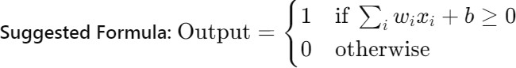The activation function in a perceptron determines the output of the perceptron based on the weighted sum of the inputs. It maps the input to an output of either 0 or 1, depending on whether the input exceeds a certain threshold.

1. What is the role of hidden layers in a Multi-Layer Perceptron?

Hidden layers in a Multi-Layer Perceptron (MLP) allow the network to learn and represent complex patterns in the data by transforming the inputs through non-linear functions multiple times before producing the output.

1. How does backpropagation update the weights in a neural network?

Backpropagation updates the weights in a neural network by computing the gradient of the loss function with respect to each weight. It uses this gradient to adjust the weights in the direction that minimizes the loss, typically using an optimization algorithm like gradient descent.

1. What is the significance of the activation function in an MLP?

The activation function introduces non-linearity into the model, enabling the MLP to capture and learn complex patterns in the data. Without non-linear activation functions, the MLP would only be able to model linear relationships.

1. Why is it important to set a maximum number of iterations (`max_iter`) when training an MLP? Setting a maximum number of iterations (`max_iter`) ensures that the training process stops even if the optimization algorithm has not converged. This prevents the model from running indefinitely and allows for control over the training time.
2. What is the purpose of the `random_state` parameter in the MLPRegressor?

The `random_state` parameter ensures reproducibility by controlling the random number generation used during the training process. This allows the same results to be obtained when the model is trained multiple times under the same conditions.

1. What is the purpose of using the `face_recognition` library in this program?

The `face_recognition` library is used for loading and handling face images, detecting faces within images, and extracting face encodings which are essential for training the SVM classifier.

1. What does the `train_test_split` function do in this program?

The `train_test_split` function splits the dataset into training and testing sets, ensuring that the model can be trained on one portion of the data and tested on another to evaluate its performance.

1. What kernel is used in the SVM classifier in this program?

The SVM classifier uses the default RBF kernel, which is indicated by the parameter

`gamma='scale'` in the `svm.SVC` initialization.

1. How are face encodings used in the context of this program?

Face encodings are numerical representations of the facial features. These encodings are used as input features for the SVM classifier to distinguish between different faces.

1. What is the significance of the accuracy metric printed by the program?

The accuracy metric indicates the percentage of correctly classified instances out of the total instances in the testing set. It gives a measure of how well the SVM classifier is performing in recognizing faces.

1. What is a Decision Tree in the context of machine learning?

A Decision Tree is a supervised learning algorithm used for classification and regression tasks. It splits the data into subsets based on the value of input features, with each split represented as a branch, and the final outcome represented as a leaf node.

1. What is the primary objective of a Decision Tree algorithm?
2. The primary objective of a Decision Tree algorithm is to create a model that predicts the value of a target variable by learning simple decision rules inferred from the data features. It aims to minimize classification error or, in the case of regression, minimize prediction error.
3. How does a Decision Tree determine the best split at each node?

A Decision Tree determines the best split at each node by evaluating various criteria such as Gini impurity, Information Gain (based on entropy), or Mean Squared Error (for regression). The split that results in the highest information gain or the lowest impurity is chosen.

1. What are some common hyperparameters used to control the growth of a Decision Tree? Common hyperparameters include `max_depth` (the maximum depth of the tree),

`min_samples_split` (the minimum number of samples required to split an internal node),

`min_samples_leaf` (the minimum number of samples required to be at a leaf node), and

`max_features` (the number of features to consider when looking for the best split).

1. What are some methods to prevent overfitting in Decision Trees? Methods to prevent overfitting in Decision Trees include:

Pruning: Removing parts of the tree that provide little power to classify instances.

Setting Maximum Depth: Limiting the depth of the tree to prevent it from growing too complex.

Minimum Samples for Split/Leaf: Setting a minimum number of samples required to split an internal node or to be at a leaf node.

Cross-Validation: Using cross-validation to tune hyperparameters and assess the model's performance on unseen data.

1. What does "Ada" in AdaBoost stand for?

"Ada" in AdaBoost stands for "Adaptive."

1. What is the main purpose of AdaBoost?

The main purpose of AdaBoost is to combine multiple weak classifiers to form a strong classifier.

1. How does AdaBoost assign weights to misclassified instances?

AdaBoost increases the weights of misclassified instances to focus on harder cases in subsequent iterations.

1. What is a weak learner in the context of AdaBoost?

A weak learner is a classifier that performs slightly better than random guessing.

1. What type of models are typically used as weak learners in AdaBoost?

Decision stumps (one-level decision trees) are typically used as weak learners in AdaBoost.

1. How does Gradient Boosting minimize the loss function?

Gradient Boosting minimizes the loss function by sequentially adding models that fit the residual errors of the combined ensemble of previous models.

1. What is the main difference between AdaBoost and Gradient Boosting in terms of how they build models?

The main difference is that AdaBoost focuses on adjusting weights of misclassified instances, while Gradient Boosting builds models to correct the residual errors of the preceding models.

1. What type of machine learning algorithm is K-Nearest Neighbors? K-Nearest Neighbors is a supervised learning algorithm.
2. What is the primary objective of the KNN algorithm?

The primary objective of the KNN algorithm is to classify a data point based on how its neighbors are classified.

1. How is the 'K' in KNN defined?

The 'K' in KNN is the number of nearest neighbors to consider when making a classification or prediction.

1. What distance metric is commonly used in KNN to find the nearest neighbors?\ The Euclidean distance is commonly used in KNN to find the nearest neighbors.
2. What is the main disadvantage of the KNN algorithm?

The main disadvantage of the KNN algorithm is its high computational cost, especially with large datasets, because it requires calculating the distance of each query point to all points in the training set.

1. Can KNN be used for regression problems?

Yes, KNN can be used for regression problems by averaging the values of the K nearest neighbors.

1. How does the choice of 'K' affect the KNN algorithm's performance?

A small 'K' can lead to overfitting, while a large 'K' can lead to underfitting. The choice of 'K' needs to balance bias and variance.

1. What type of machine learning algorithm is K-Means? K-Means is an unsupervised learning algorithm.
2. What is the primary objective of the K-Means algorithm?

The primary objective of the K-Means algorithm is to partition the data into K clusters, where each data point belongs to the cluster with the nearest mean.

1. How is the 'K' in K-Means defined?

The 'K' in K-Means is the number of clusters to form in the data.

1. What is the first step in the K-Means clustering process?

The first step in the K-Means clustering process is to randomly initialize K centroids.

1. How do you assign data points to clusters in K-Means?

Data points are assigned to the cluster with the nearest centroid, based on the Euclidean distance.

1. What happens after data points are assigned to clusters in K-Means?

After data points are assigned to clusters, the centroids are recalculated as the mean of all points in each cluster, and the process is repeated until convergence.

1. What is a common method to determine the optimal number of clusters in K-Means?

A common method to determine the optimal number of clusters is the Elbow Method, which involves plotting the within-cluster sum of squares (WCSS) against the number of clusters and looking for an 'elbow' point where the rate of decrease sharply slows down.

1. What is Principal Component Analysis (PCA)?

Principal Component Analysis (PCA) is a statistical technique used to reduce the dimensionality of a dataset while retaining most of the variation in the data.

1. How is a principal component defined in PCA?

A principal component is a linear combination of the original variables that captures the maximum variance in the data.

1. What is the purpose of using PCA?

The purpose of PCA is to simplify the complexity in high-dimensional data while retaining trends and patterns by transforming the data to a new set of variables (principal components).

1. What does an eigenvalue represent in the context of PCA?

An eigenvalue represents the amount of variance captured by each principal component. Larger eigenvalues indicate that the principal component accounts for more variance in the data.

1. Why is it important to standardize the data before performing PCA?

Standardizing the data is important because PCA is affected by the scale of the variables. Standardization ensures that each variable contributes equally to the analysis.

1. How do you determine the number of principal components to retain in PCA?

The number of principal components to retain is typically determined by the cumulative explained variance, choosing enough components to capture a high percentage (e.g., 90-95%) of the total variance.

1. What are the advantages of using PCA for dimensionality reduction?

The advantages of using PCA include reducing the dimensionality of the data, which simplifies analysis, reduces computational cost, and mitigates the risk of overfitting while retaining the essential patterns and relationships in the data.